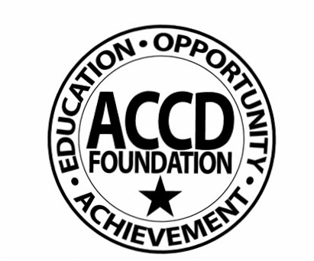
DONATION FORM
(Non-Monetary Donations are not to be accepted prior to approval. Non-monetary gifts are gifted directly to the ACC. This form will still be used for internal reporting purposes.)
ALAMO COMMUNITY COLLEGES & ACCD FOUNDATION INC.
ACC Office of Institutional Advancement
201 W. Sheridan, Suite C-3, San Antonio, TX 78204 210-485-0044
)
DATE:_______________

DONOR(s) Destination:
Name/Organization NLC NVC

Address PAC SAC

City/State/Zip SPC

Telephone DISTRICT WIDE

THE FOLLOWING MUST BE ATTACHED TO THIS FORM:
- Donor’s Check (Cash should be hand delivered to the Foundation Office) & any accompanying documents (Please keep a copy of the check and any documents for your files).
- Letter from the donor(s) indicating desire to make the donation(s) for Gifts-In-Kind.
MONETARY DONATIONS:
Amount $

Recipient Department/Program:

Designated Fund (Scholarship or Program):

Banner Account #: Foundation Fund: .
(xxxxx-xxxxx-5751R-xxx)

GIFT-IN-KIND DONATIONS (items, equipment, certificates, etc.):

Responsibility and associated cost for transporting and installing equipment to be borne by:
 Donor  ACC If ACC, estimated cost $
 Solicitor has personally inspected donation(s) and certifies need for same.
The equipment does  does not  require a Service Maintenance Contract.
Annual Cost $ Source of Maintenance
Will the cost of the maintenance contract also be donated? Yes  No 

Donor’s Estimated of Value of Gift: $ (This amount is determined by the donor or their appraiser per IRS Regulations. Staff may not assign a value. A value of zero is acceptable).

SIGNATURES:
PROGRAM DIRECTOR/ Phone
BUDGET MANAGER
Printed Name Email
DEVELOPMENT OFFICER Phone
Printed Name Email
COLLEGE/DISTRICT
BUDGET OFFICER Phone
Printed Name Email
COLLEGE PRESIDENT

THE ABOVE DESIGNATED GIFT(S) MEETS THE REQUIREMENTS FOR ACCEPTANCE.

DATE ACCEPTED:
Richard Drum, Interim Executive Director ACCD Foundation Inc. & AC Institutional Advancement
Revised 07-2009

